June Cherry Recipe Contest Landing Page Copy
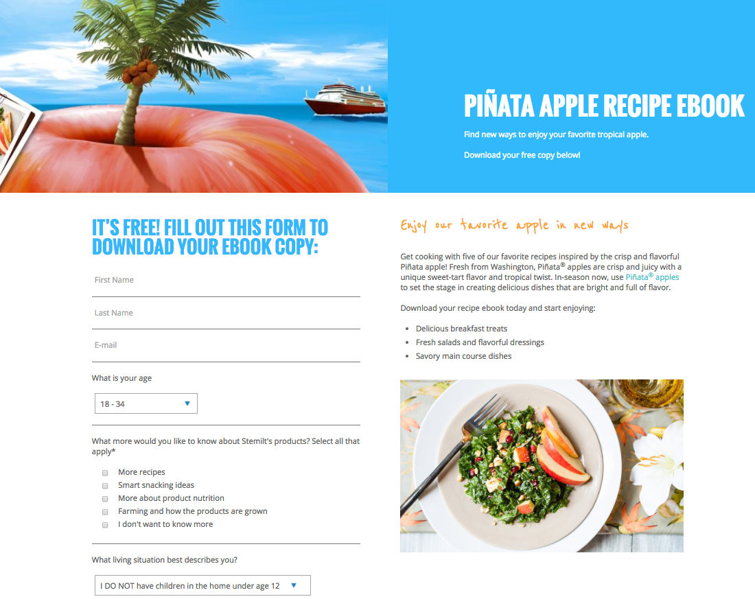

Header Copy

Description
Description Headline
Hubspot Form Headline

Hubspot Form Fields

Header Copy:
Pit Your Skills to the Test – A Cherry Recipe Contest
Submit an original cherry recipe for the chance to win a very cherry prize pack!

Hubspot Form Headline: Submit Your Cherry Recipe Here:

Hubspot Form Fields:
- First
- Last
- E-mail
- What is your age?
- What more would you like to know about Stemilt’s products? Select all that apply*
- What living situation best describes you?
- What is your zip code?
- File upload: cherry recipe (Word doc or PDF files only)
- File upload (hi-res): recipe image (jpeg, png)
- I agree to the Terms & Conditions.

Description Headline: Submit your favorite cherry recipe to win!

Description:
The recipe options you can make with cherries are endless – from pie and cobbler to refreshing salads and drinks – and we’re looking for you to submit your favorite original recipe using one of summer’s sweetest fruits. One lucky winner will receive a fresh shipment of cherries from our Washington State orchards along with cooking supplies, cherry swag and a $100 Visa gift card!

How to do you enter? It’s easy! Complete the form to the left with your recipe and a hi-res photo of the recipe by July 31, 2017.

Cherry Recipe Contest Thank You Page Copy
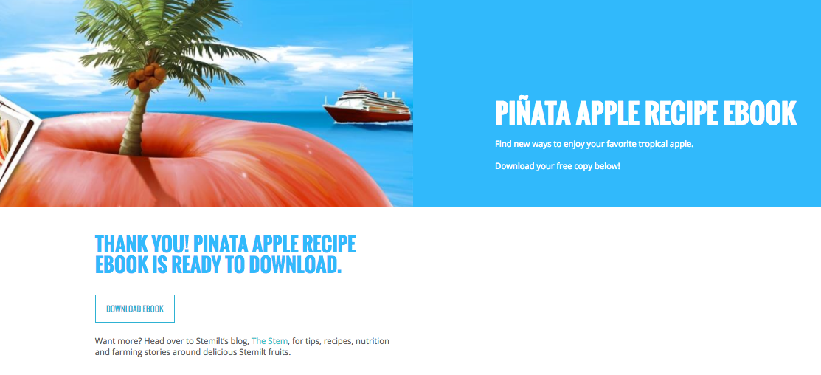

Header Copy

Thank You Headline

Secondary CTA

Header Copy: Pit Your Skills to the Test – A Cherry Recipe Contest

Thank you Headline: Thank you for submitting your cherry recipe!

Add paragraph under Headline: We will be selecting one lucky winner to receive a shipment of our Washington-grown cherries along with cooking supplies, cherry swag and a $100 Visa gift card by Aug. 4, 2017. Please keep an eye out for an email from us or watch our Facebook page for the official announcement.

Secondary CTA: Have friends or family you think should enter? Share on Facebook or Twitter.

