Chocolate Covered Cherry Cloud
By: Rumie Martinez

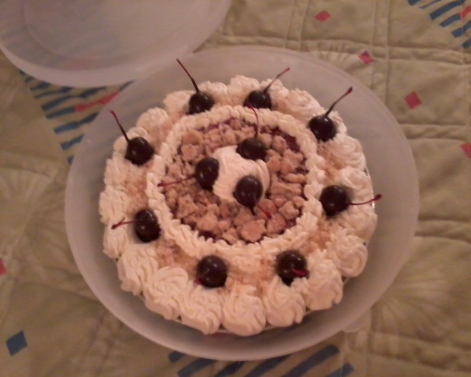

Crust:
1 single crust (Homemade is the best but fridge crust will also work.)

Filling:
1 ½ Cups granulated sugar
4 Tablespoons cornstarch
¼ teaspoon salt
1 Tablespoon butter, softened
3 (14 ½ ounce) cans pitted tart cherries, drained – reserving ½ cup of the juice OR
1 lb Fresh Tart Cherries = 2 1/3 Cups pitted
NOTE: Fresh Cherries is always the best but canned or frozen will also work.
3 drops red food coloring
3/4 teaspoon almond extract
2 Tablespoons of Cherry Juice Concentrate
1 teaspoon lemon juice
Directions below….

Shortbread Cookie Topping:
1 Cup salted butter, cold and cut into pieces
½ Cup packed light brown sugar
2 ¼ Cups all purpose flour
Bake this before so it will be cool and you can crumble it.
Preheat oven to 325 degrees. Roll out and place on cookie sheet. This does not have to be pretty since you will be crumbling it up but you won’t need a lot so you can make some of this batter into cookies to eat later. Bake for 15-20 minutes, remove and let completely cool.

Whipped Cream Topping:
Can use store bought but homemade stabilized whipped cream is best.
1 teaspoon of unflavored gelatin
4 teaspoons cold water
1 Cup heavy whipping cream
½ to ¾ Cup of powdered sugar (depends on your taste and how sweet you like it)
½ teaspoon of pure vanilla extract
Place gelatin in small bowl with the cold water and let this set for about 5 minutes so it can desolve. Then whip the heavy whipping cream, powdered sugar and vanilla in a bowl using an electric beater. To use the gelatin, place bowl in microwave for about 5 to 10 seconds to re-melt back to liquid form. Don’t over heat, you do not want it hot when you use it in your heavy whipping cream. Then slowly pour it into your whipped cream while continuing to whip your cream. Continue beating the cream until you see medium to stiff peaks forming. Spoon this into a piping bag and tip and keep it in fridge until ready to use.

Cherries for Topping:
Can use Fresh Black Sweet Cherries dipped in chocolate or Maraschino Cherries dipped in chocolate; you will need about 12 cherries for the topping; more if you eat any while making them.
Melt chocolate chips (I like to use milk chocolate chips for these but semi-sweet is also good) over a double boiler or microwave, once melted, dipped a cherry into the chocolate and let them set on waxed or parchment paper until they have harden. Note: if you dry off your cherries with a paper towel before dipping, the chocolate will adhere better.

Baking Instructions for Pie:
- Preheat oven to 400 degrees
- Drain cherries, reserving ½ cup of juice.
- Combine sugar, cornstarch and salt in a small bowl and mix together and set aside.
- Combine reserved cherry juice, food coloring, almond extract, cherry juice concentrate and lemon juice. Add the liquids to the dry ingredients and mix well. Cook in sauce pan until thickened.
- Combine this with the drained cherries and mix well.
- Add the softened butter and let stand for 10 - 15 minutes.
- Cool cherry mixture for a little bit before pouring into your pie crust.
- Bake for 15 minutes at 400 degrees, then lower oven temp to 350 degrees and finish baking until your crust is baked. Approximately another 20 – 30 minutes. Depends on your oven so keep a watchful eye.
- Remove and let pie cool completely on a wire rack.

NOTE: If crust edges begin to look too dark, cover with strips of tin foil or use a pie crust shield to prevent over browning.

- Once your pie is baked and completely cooled, place your shortbread crumb topping on top of the cherry mixture in the center (approximately a 4 inch circle) and around the edge of the pie. See picture.
- Then pipe your whipped topping around the edges of your pie and around the edges of your shortbread crumb topping. Then place your chocolate covered cherries on your pie in one of your piped rosettes and you are done.
- Keep pie in fridge until ready to eat.

